**Corner floating shelves solid wood**

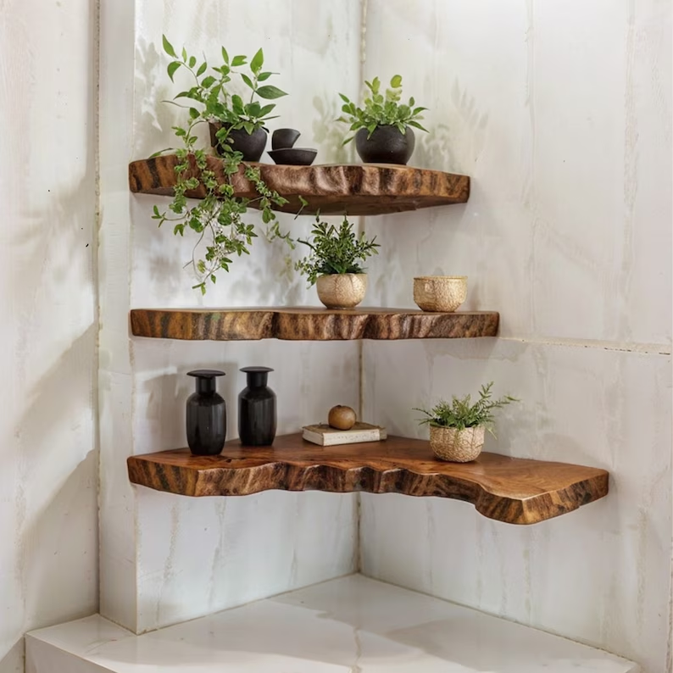Corner Floating Shelves made of solid wood are a timeless and durable solution for optimizing corner spaces while adding a touch of natural elegance to any room. These shelves are crafted from high-quality, solid wood, ensuring long-lasting sturdiness and a refined look that complements a variety of interior styles, from rustic to modern. The floating design gives a clean, minimalist appearance, allowing the wood's grain and texture to stand out as a beautiful focal point. Ideal for displaying books, plants, or decor, these shelves not only provide functionality but also elevate the aesthetic of your living room, bedroom, or office.

.